# Python test 5
# q1
D = [1000, 500, 200, 100, 50, 20, 10, 5]
amount = int(input("Enter amount : "))

note_1000 = amount // D[0]
print("Notes of 1000 :" , note_1000)
amt1 = amount % D[0]
print("Amount one :" , amt1)

note_500 = amt1 // D[1]
print("Notes of 500 :" , note_500)
amt2 = amt1 % D[1]
print("Amount two :" , amt2)

note_200 = amt2 // D[2]
print("Note of 200 :" , note_200)
amt3 = amt2 % D[2]
print("Amount three :" , amt3)

note_100 = amt3 // D[3]
print("Notes of 100 :" , note_100)
amt4 = amt3 % D[3]
print("Amount four :" , amt4)

note_50 = amt4 // D[4]
print("Notes of 50 :" , note_50)
amt5 = amt4 % D[4]
print("Amount five :",amt5)

note_20 = amt5 // D[5]
print("Notes of 20 :" , note_20)
amt6 = amt5 % D[5]
print("Amount six :",amt6)

note_10 = amt6 // D[6]
print("Notes of 10 :" , note_10)
amt7 = amt6 % D[6]
print("Amount seven :",amt7)

note_5 = amt7 // D[7]
print("Notes of 5 :" , note_5)
amt8 = amt7 % D[7]
print("Amount seven :",amt8)

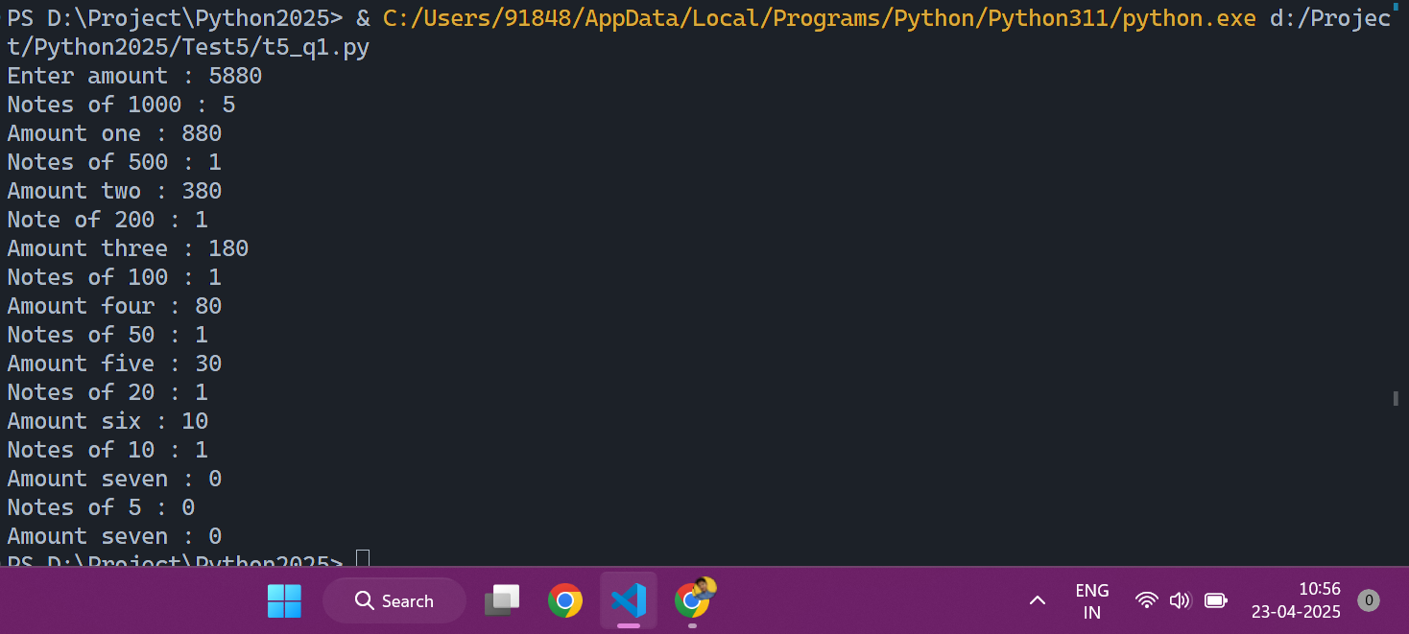

# q2
def find_missing_coin(coins):
missing = 0
for coin in coins:
missing ^= coin
return missing
n = 8
coins = [5, 7, 2, 7, 5, 2, 5]
print(n)
print(coins)
print(find_missing_coin(coins))
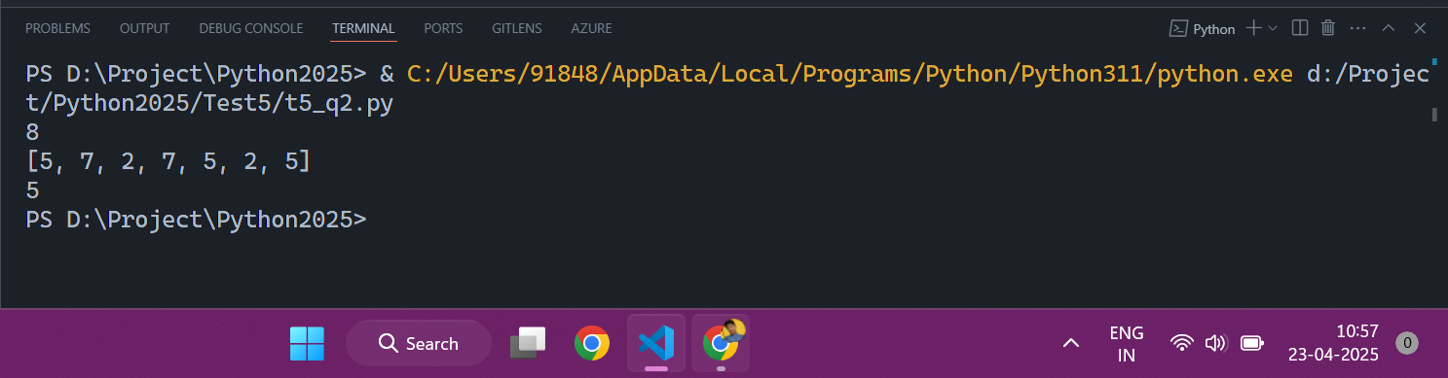

# q3
Data = [
[ 101, "Seema",45000 ] ,
[ 340, "Rajani", 13000 ] ,
[ 210, "Tannu", 14000 ] ,
[ 320, "Suresh", 35000 ] ]

for i in range(len(Data)):
for j in range(i,len(Data) - i - 1 ):
if Data[j][2] > Data[j + 1] [2]:
Data[j],Data[j + 1] = Data[j + 1],Data[j]

print(Data)

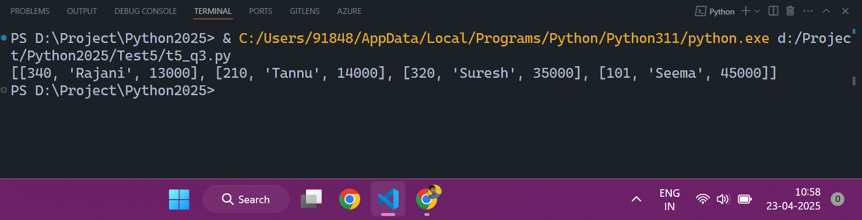

# q4
list1 = [1,3,4,1,2,3,6,7,1,2,4]
print(list1)
md = dict()
for element in list1:

if( element in md ):
md[element] += 1

else:
md[element] = 1

print(md)

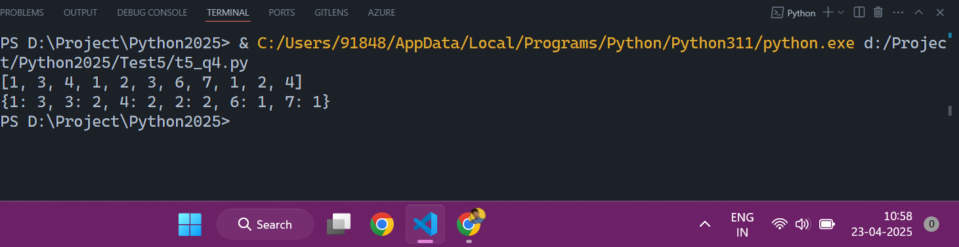
# q5

l1 = [1,2,3,4,5]
l2 = [1,2,6,7,8,9,70]
new_list = []
l3 = l1 + l2
for i in l3:
if (i not in new_list):
new_list.append((i))
print(new_list)

